

**Project 5 For Diploma in AI and its application in Business:**

**Face Recognition with Siamese Network and its variants**

**Project Report**

*Face Recognition and Example Implementation of Siamese Network Architecture*

Prepared by: Chen Yijie

Supervisor: Zhou Changxin

Table of Contents

Project Overview: 4

Covering Concepts: 4

Potential Use Case: 6

Environment Used: 8

Dataset Used 8

Preprocessing: 9

Siamese Network Implementation: 13

Training Parameter: 15

Initial Results: 18

Siamese Contrastive Model 20

Siamese Resnet Contrastive Model 23

Intermediate Result 24

Siamese Cosine Similarity Model 26

Intermediate Result 27

Face Extraction 29

Final Result 32

Potential Improvements 34

Conclusion: 34

**Project Overview:**   
The project aims to implement a simple face recognition system using Siamese Neural Networks, a specialized architecture adept at comparing pairs of images to discern subtle differences and similarities between faces to achieve one shot classification. By learning meaningful representations of facial features through the generation of facial embeddings, the system can generalize well to unseen faces and handle variations in pose, lighting, and facial expressions effectively. With applications in security, access control, and personalized user experiences, the project endeavors to optimize the face recognition system for high accuracy and efficiency, leveraging the power of Siamese Networks to achieve reliable identifications even in challenging conditions. Through this effort, the project seeks to contribute to advancements in facial recognition technology, facilitating innovative applications across diverse industries.

## **Covering Concepts:**

1. **Convolutional Neural Network (CNN**)**:** CNNs are employed for feature extraction from facial images. They consist of convolutional layers that capture spatial features relevant for face recognition.
2. **Pooling:** Pooling layers in CNNs downsample feature maps to reduce computational complexity while retaining important facial features. Techniques like max pooling help in preserving relevant information.
3. **Siamese Network Architecture:** Siamese networks are designed to learn similarity between pairs of facial images. They consist of twin CNN branches with shared weights, enabling them to learn discriminative features effectively.
4. **Euclidean Distance:** The distance between 2 vector embeddings, usually a representation of how different the 2 embeddings are.
5. **Triplet Loss Function:** Triplet loss function is another option used in siamese networks, where each training sample consists of an anchor image, a positive image (similar to the anchor), and a negative image (dissimilar to the anchor). It optimizes the network to minimize the Euclidean distance between anchor-positive pairs and maximize the distance between anchor-negative pairs.
6. **Contrastive Loss Function:** The contrastive loss function is utilized in siamese networks to optimize the similarity between pairs of facial images. It penalizes the distance between similar pairs while pushing dissimilar pairs apart in the learned feature space.
7. **Face Embeddings:** Siamese networks generate embeddings for facial images, which represent unique features of each face in a compact and discriminative manner. These embeddings are used for face recognition by measuring distances or similarities between embeddings of different faces.
8. **One-shot Learning:** Siamese networks facilitate one-shot learning by learning to recognize faces from a limited number of training samples. This is achieved by training the network to distinguish between pairs of images, making it effective for scenarios with scarce training data.
9. **Fine-tuning:** Fine-tuning involves adjusting the parameters of a pre-trained siamese network using a small dataset of facial images specific to the target recognition task. This process enhances the network's ability to recognize faces accurately in a particular domain.
10. **Verification and Identification:** Siamese networks can be used for both face verification (determining if two faces belong to the same person) and face identification (assigning identities to faces). These tasks are achieved by comparing embeddings or distances between facial images.
11. **Evaluation Metrics:** Evaluation metrics such as accuracy, precision, recall, and F1-score are commonly used to assess the performance of siamese networks in face recognition tasks. These metrics quantify the network's ability to correctly classify faces and distinguish between different individuals accurately.

## **Potential Use Case:**

A well-trained Siamese Network for one shot classification can find application in various domains where there is a lack of dataset. Here are some potential use cases:

1. **Access Control and Security:** Siamese networks can be deployed for access control systems in secure environments such as offices, government facilities, and residential buildings. The system can verify individuals' identities by comparing their facial features with stored templates, enhancing security and preventing unauthorized access.
2. **Biometric Authentication:** Siamese facial recognition can be integrated into devices like smartphones, tablets, and laptops for biometric authentication. Users can unlock their devices, access sensitive data, and make secure transactions using facial recognition, providing a convenient and secure authentication method.
3. **Surveillance and Monitoring:** Law enforcement agencies and security firms can utilize siamese facial recognition systems for surveillance and monitoring purposes. The system can analyze live or recorded video feeds to identify individuals of interest, track their movements, and enhance situational awareness in public spaces, airports, and other high-security areas.
4. **Customer Experience Enhancement:** Retailers and businesses can implement siamese facial recognition to personalize customer experiences. By recognizing loyal customers as they enter the store, businesses can offer tailored recommendations, discounts, and promotions based on past purchase history and preferences, enhancing customer satisfaction and loyalty.
5. **Attendance Tracking:** Educational institutions, corporate offices, and event organizers can automate attendance tracking using siamese facial recognition systems. Students, employees, or attendees can check in and out of premises by simply facing a camera, eliminating the need for manual attendance registers and improving efficiency.
6. **Identity Verification and Fraud Prevention:** Siamese facial recognition can be used for identity verification and fraud prevention in various industries such as banking, e-commerce, and healthcare. The system can verify users' identities during account registration, login, or transaction authentication, reducing the risk of identity theft and fraudulent activities.
7. **Customized Content Delivery:** Media and entertainment platforms can leverage siamese facial recognition to deliver personalized content recommendations to users. By analyzing users' facial expressions and reactions while watching videos or interacting with content, platforms can tailor content suggestions to match their preferences and interests.
8. **Healthcare Applications:** Siamese facial recognition systems can assist healthcare providers in patient identification and medical record management. By accurately matching patients' faces with their electronic health records, hospitals and clinics can ensure proper patient care, streamline administrative processes, and reduce medical errors.
9. **Lost and Found Recovery:** Siamese facial recognition can aid in the recovery of lost or stolen items by matching individuals' faces captured on surveillance cameras with database records. This can help law enforcement agencies and businesses identify suspects and recover lost property more effectively.
10. **Emotion Recognition and Behavioral Analysis:** Siamese facial recognition systems equipped with emotion recognition capabilities can analyze facial expressions to infer users' emotions and behavioral patterns. This information can be valuable for market research, customer feedback analysis, and psychological studies, enabling organizations to better understand and respond to human emotions.

## **Environment Used:**

Python programming language with:

1. tensorflow = ^2.15.0

2. keras = ^2.15.0

3. tensorboard = ^2.15.0

4. numpy = ^1.26.3

5. matplotlib = ^3.8.2

6. scikit-learn = ^1.3.2

## **Dataset Used**

For this project, the dataset used will be the Labeled Faces in the Wild (LFW) dataset available on Kaggle. The Labeled Faces in the Wild (LFW) dataset is a widely utilized benchmark in face recognition and computer vision, comprising 13,233 internet-sourced images of 5,749 individuals. These images exhibit substantial variability in pose, illumination, expression, occlusion, and background clutter, posing challenges for algorithms. Each image is labeled with the depicted person's identity, facilitating supervised learning and algorithm evaluation. Typically divided into training and testing sets, the dataset's evaluation protocol involves verifying whether pairs of face images belong to the same individual. Performance is commonly measured in verification accuracy, assessing the algorithm's ability to correctly classify pairs. Despite its popularity, LFW presents challenges like variations in pose, illumination, and ethnicity. Nonetheless, it has significantly contributed to advancing face recognition research and serves as a standardized benchmark for algorithm evaluation.

## **Preprocessing:**

The dehaze dataset images needs to be prepared into original images and hazy image pair for training to take place. Some of the common preprocessing practices are used to prepare the datasets:

1. **Getting a List of All Subfolders:** The main dataset directory typically contains subfolders, each representing an individual's collection of images. By traversing through these subfolders, we can obtain a comprehensive list of all individuals included in the dataset. This initial step sets the groundwork for further analysis and organization of the data.

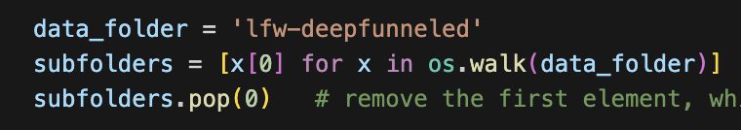

Fig 1. Code Implementation to Get List of All Subfolders

1. **Loop Through All Folders to Count Images:** Iterating through each subfolder allows us to examine the contents of each individual's photo collection. Counting the number of images available for each person helps in identifying individuals with sufficient data for training. This step is crucial for filtering out individuals who may have insufficient data, ensuring that the resulting dataset is suitable for training a siamese network effectively.

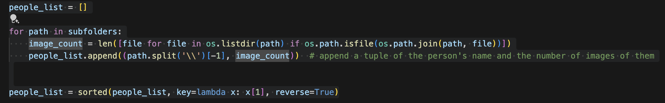

Fig 2. Code Implementation to Count Images in Each Subfolder

1. **Create a Separate Folder for Individuals with 5 or More Photos:** Filtering out individuals with five or more photos ensures that the dataset contains a sufficient number of samples per person for meaningful training. This threshold is chosen based on the minimum data requirement for effective training of a siamese network. Creating a separate folder for these individuals streamlines the subsequent preprocessing steps and ensures that the final dataset comprises individuals with adequate representation.

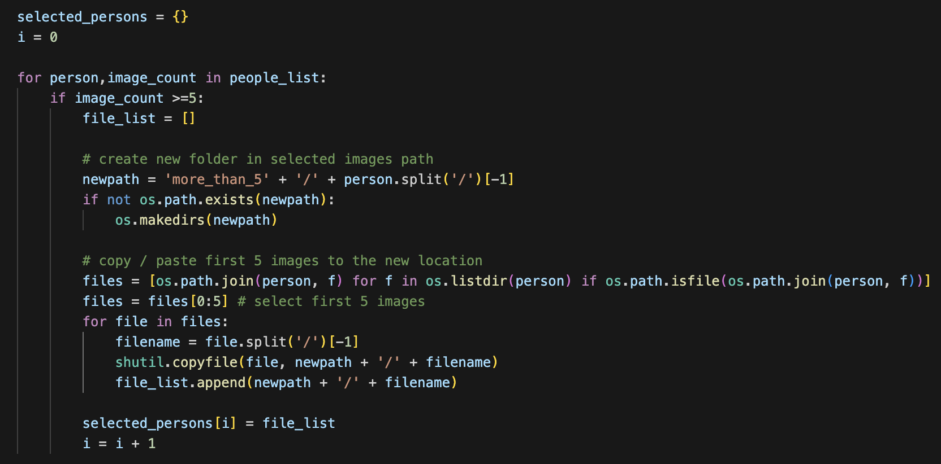

Fig 3. Code Implementation to Filter Only People with 5 or More Photos

1. **Arranging Data in Triplets:** Siamese networks are trained using triplets of images: an anchor image (image of the same person), a positive image (another image of the same person), and a negative image (image of a different person). By organizing the data into triplets, the network learns to discriminate between similar and dissimilar faces effectively. This arrangement facilitates the learning of discriminative features essential for face recognition tasks.

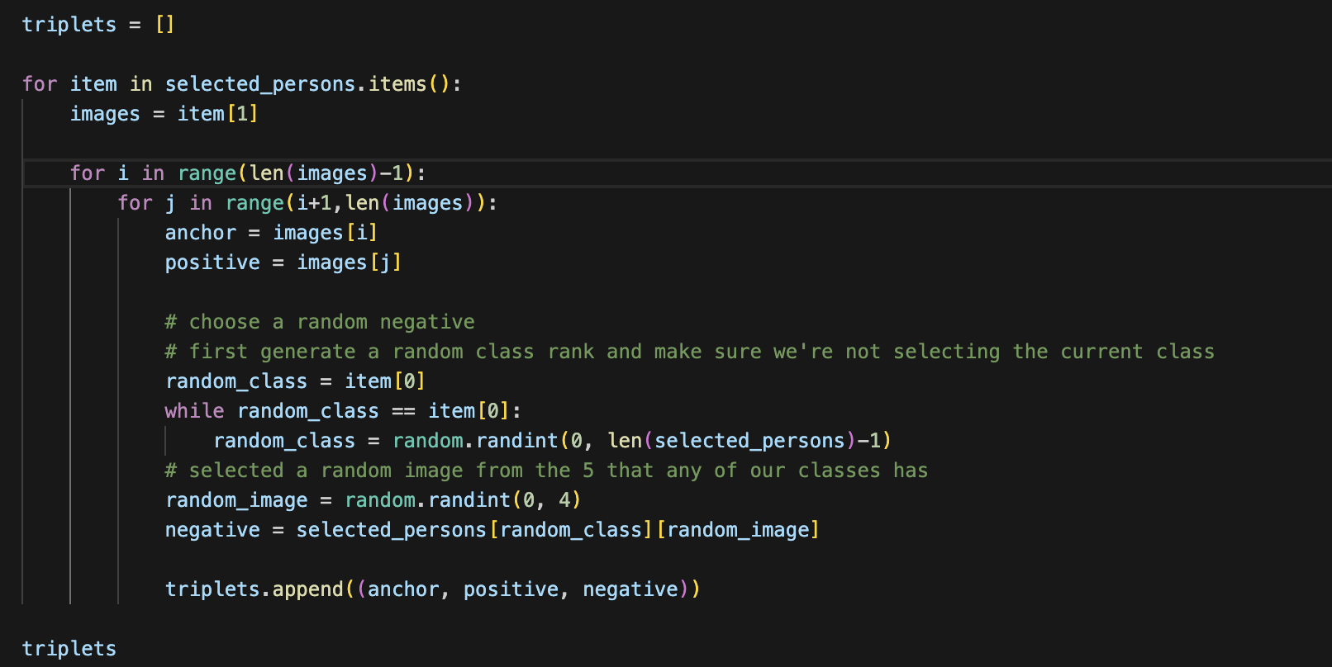

Fig 4. Code Implementation to Group Images into Triplets

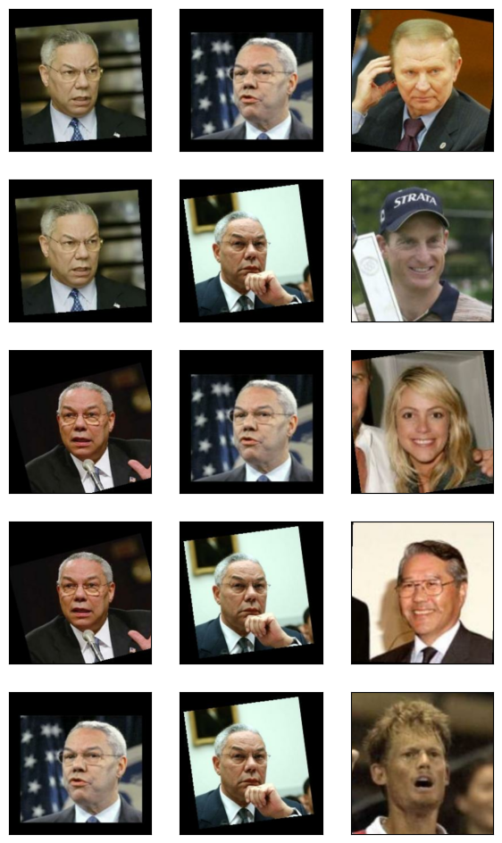

Fig 5. Sample Triplets Visualization

1. **Define Function that Load JPEG Images and Resize:** Loading JPEG images and resizing them to a uniform size ensures consistency in the input dimensions across the dataset. Resizing the images to a standard resolution, such as 256x256 pixels, reduces computational complexity and ensures compatibility with deep learning frameworks. Additionally, converting images to RGB integer data prepares them for further processing and feature extraction.

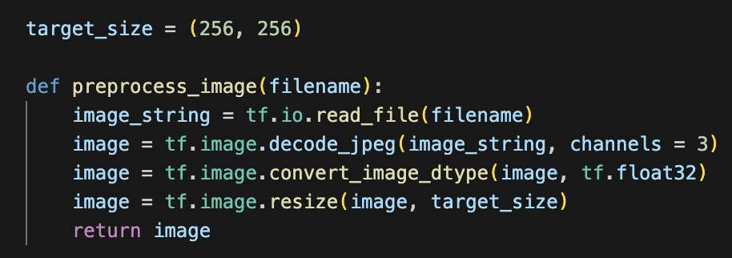

Fig 6. Code Implementation to Load and Translate Jpeg Images

1. **Shuffle the Data:** Shuffling the data randomly reorders the triplets within the dataset. This step prevents the model from learning spurious correlations or biases associated with the order of the data. By introducing randomness, the siamese network learns more robust and generalizable representations of facial features, leading to better performance on unseen data.

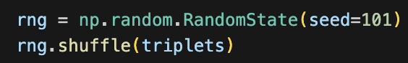

Fig 7. Code Implementation to Shuffle Datasets

1. **Load Dataset and Split into Training and Testing:** After preprocessing the data, it is split into training and testing sets to assess the model's performance accurately. The training set is used to optimize the siamese network's parameters, while the testing set evaluates its performance on unseen data. This split ensures that the model's ability to generalize to new faces is adequately assessed and helps prevent overfitting to the training data.

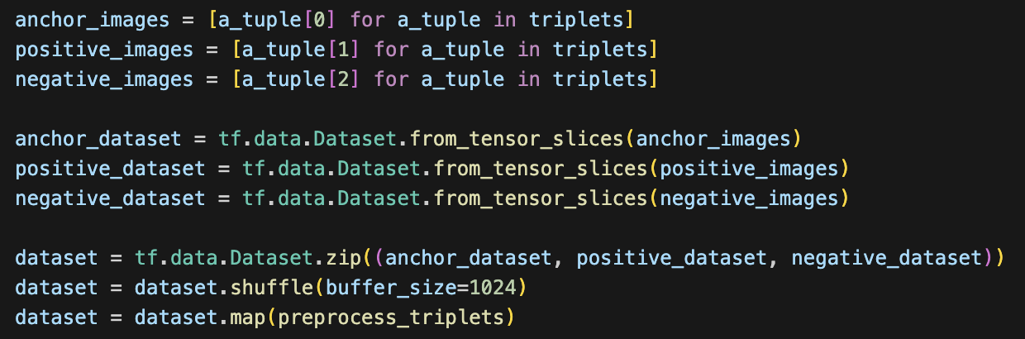

Fig 8. Code Implementation to Load Dataset

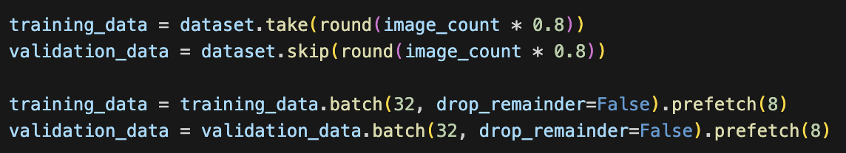

Fig 9. Code Implementation to Split Dataset

## **Siamese Network Implementation:**

Siamese Network simply feeds 2 inputs into the feature extraction block and compare the context embedding vector output.

The first Siamese Model Implementation in this project is simple a context extracting network consists of several convolutional layers, max pooling layers, drop out layers and dense layer.

1. **Convolutional Layers**: Convolutional layers are fundamental building blocks in deep learning architectures for image processing tasks. These layers use learnable filters to convolve over the input image, extracting features such as edges, textures, and patterns. Each filter captures different aspects of the input image, allowing the network to learn hierarchical representations of the input data. In the model, the convolutional layers are implemented inside a convolutional block inclusive of a convolutional layer, a activation ReLU function to bound the output from 0 to infinity and a local response normalization layer to enhance contrast.

The number of filters in each convolutional layer determines the depth of feature extraction, with deeper layers capturing more abstract and complex features. The model contains multiple convolutional blocks with different filter sizes from depth 32 to depth 256, ensuring maximum retainment of information.

1. **Max Pooling Layers**: Max pooling layers are used to downsample the spatial dimensions of feature maps obtained from convolutional layers. They operate by dividing the input feature map into non-overlapping regions and retaining only the maximum value within each region. In the model, Max Pooling Layers is introduced after all the convolutional blocks to reduce the computational complexity of the network and help to extract the most salient features while preserving spatial information. Max pooling layers also introduce a degree of translational invariance, making the network more robust to variations in object position within the input images.
2. **Dropout Layers**: Dropout layers are a regularization technique used to prevent overfitting in deep neural networks. In our model, a dropout layer is introduced in-between convolutional blocks randomly deactivating 50% of neurons in the network, forcing the model to learn redundant representations and preventing it from relying too heavily on specific features. This stochastic regularization helps improve the generalization performance of the model by reducing the likelihood of overfitting to the training data.
3. **Dense Layers**: Dense layers, also known as fully connected layers, are used to perform high-level reasoning and classification based on the features extracted by earlier layers. Each neuron in a dense layer is connected to every neuron in the preceding layer, allowing for complex interactions and nonlinear transformations of the input data. In the context of one-shot classification, dense layers are typically used in the final stages of the network to map the extracted features to the output classes or labels. These layers enable the network to make predictions based on the learned representations of the input images.

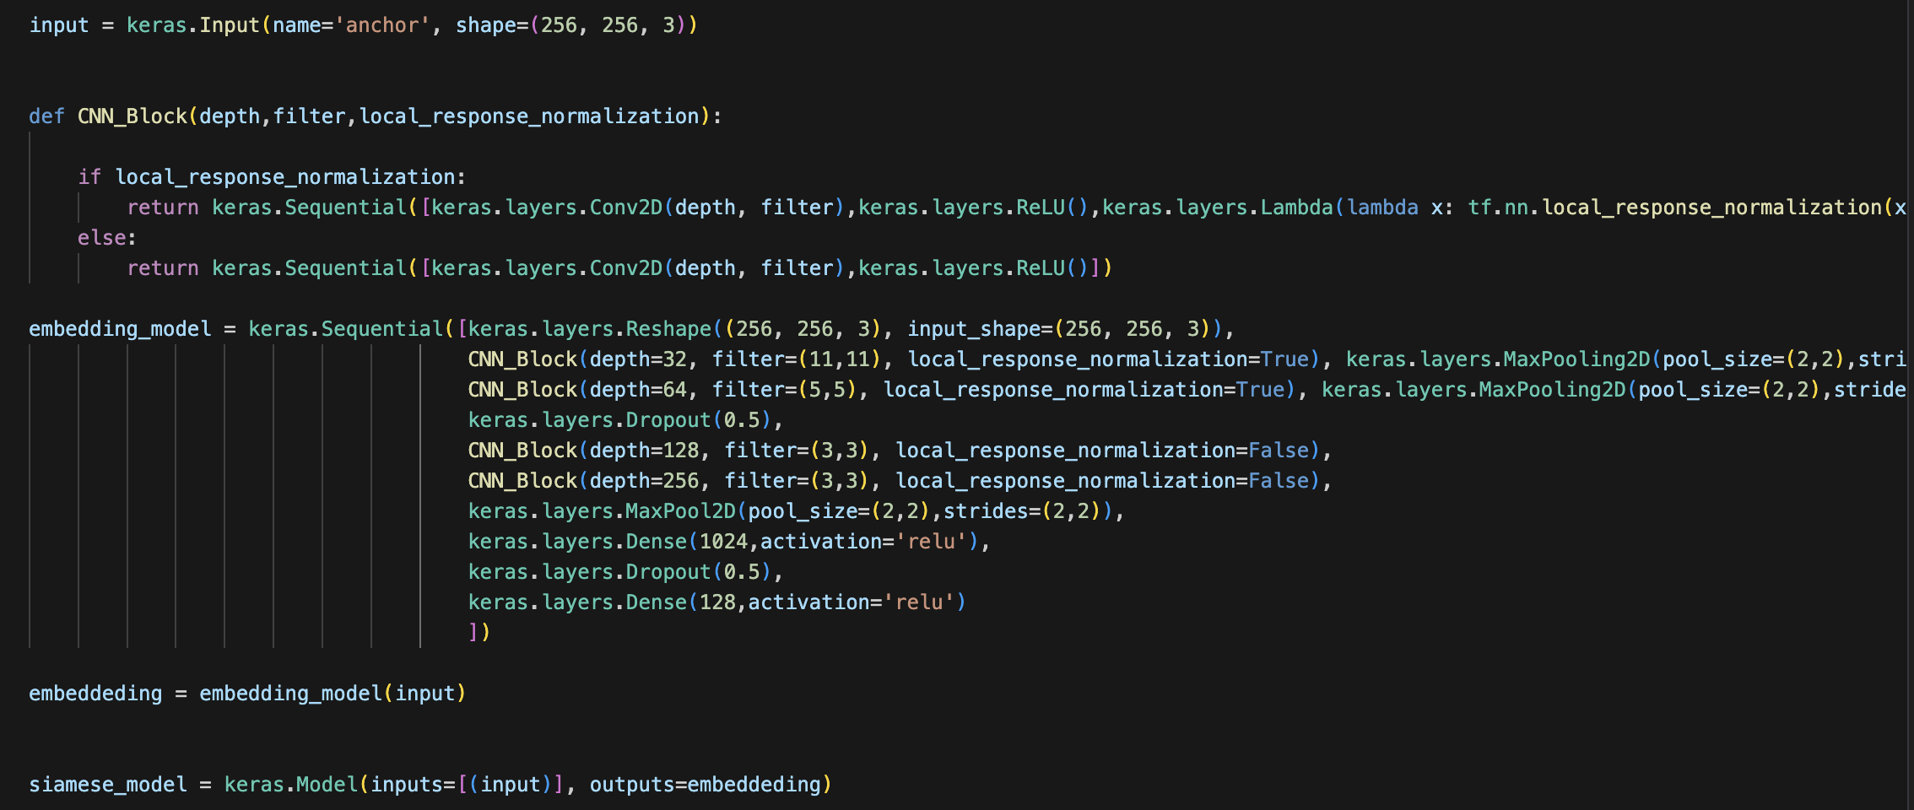

Fig 10. Code Implementation of Siamese Model

## **Training Parameter:**

1. **Triplet Loss**: The triplet loss function is specifically designed for training Siamese Networks for tasks like one-shot classification. The triplet loss in our model is implemented by returning the difference between Euclidean distances from anchor and positive image and anchor and negative image. To ensure that the model is still training and not return negative taining loss, an integer margin of 0.5 is added to the loss function. The implementation of triplet loss encourages the network to learn embeddings such that the distance between the anchor image and the negative image (images of different classes) is maximized, while the distance between the anchor image and the positive image (images of the same class) is minimized. This ensures that similar images are grouped closely together in the embedding space, facilitating accurate classification with minimal training data.

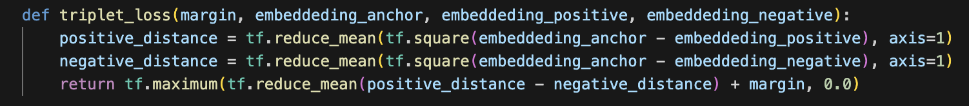

Fig 11. Code Implementation of Triplet Loss

1. **Adam Optimizer**: The Adam optimizer is a popular choice for training deep neural networks, including Siamese Networks. It combines the advantages of both AdaGrad and RMSProp optimizers by maintaining per-parameter learning rates and adapting them based on the exponential moving averages of gradients. Adam optimizes the training process by efficiently updating model parameters, accelerating convergence, and handling sparse gradients. Its adaptive learning rate mechanism helps navigate the optimization landscape effectively, making it suitable for training Siamese Networks.
2. **Learning Rate of 0.0001**: The learning rate determines the step size taken during gradient descent optimization. A learning rate of 0.0001 is chosen as a moderate value that balances between convergence speed and stability. Lower learning rates allow for more precise updates to the model parameters, preventing overshooting and ensuring smoother convergence. Additionally, a lower learning rate is beneficial for Siamese Networks training, as it allows the network to learn discriminative embeddings gradually, especially in tasks with limited training data like one-shot classification.



Fig 12. Code Implementation to Set Adam Optimizer and Its Learning Rate

1. **50000 Steps of Training**: The number of training steps defines the duration or budget for training the Siamese Network. By setting it to 50000 steps, sufficient iterations are provided for the network to learn meaningful embeddings and optimize its parameters effectively. Training for an adequate number of steps allows the network to capture the underlying patterns in the data, refine its representations, and improve classification performance. Additionally, monitoring the training progress over a fixed number of steps facilitates better evaluation and adjustment of the model's performance.

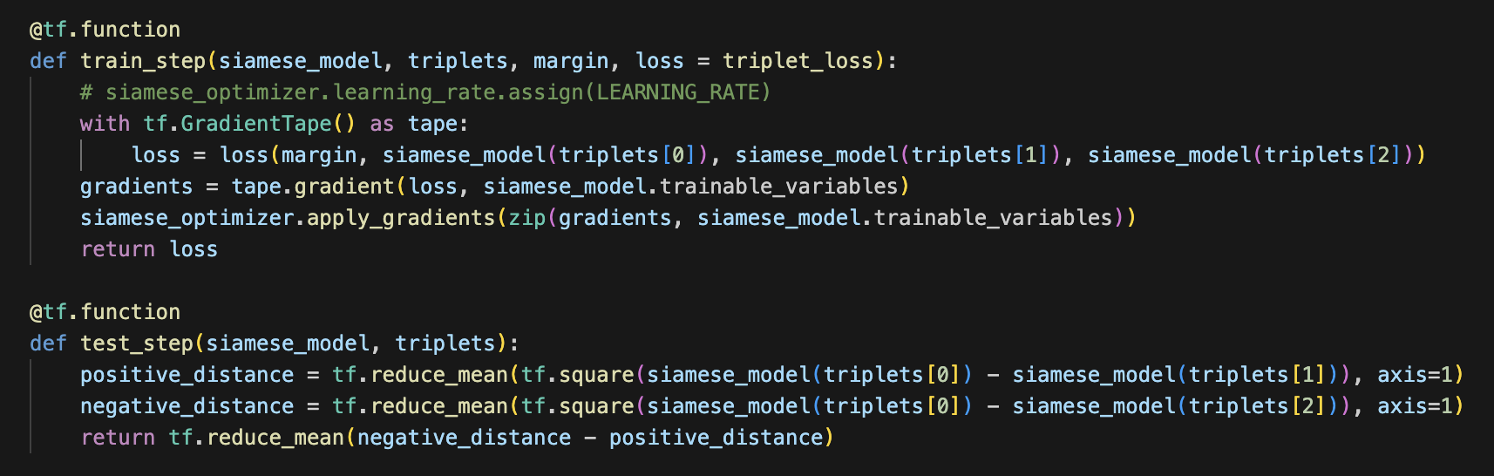

Fig 13. Code Implementation of Custom Training & Testing Step

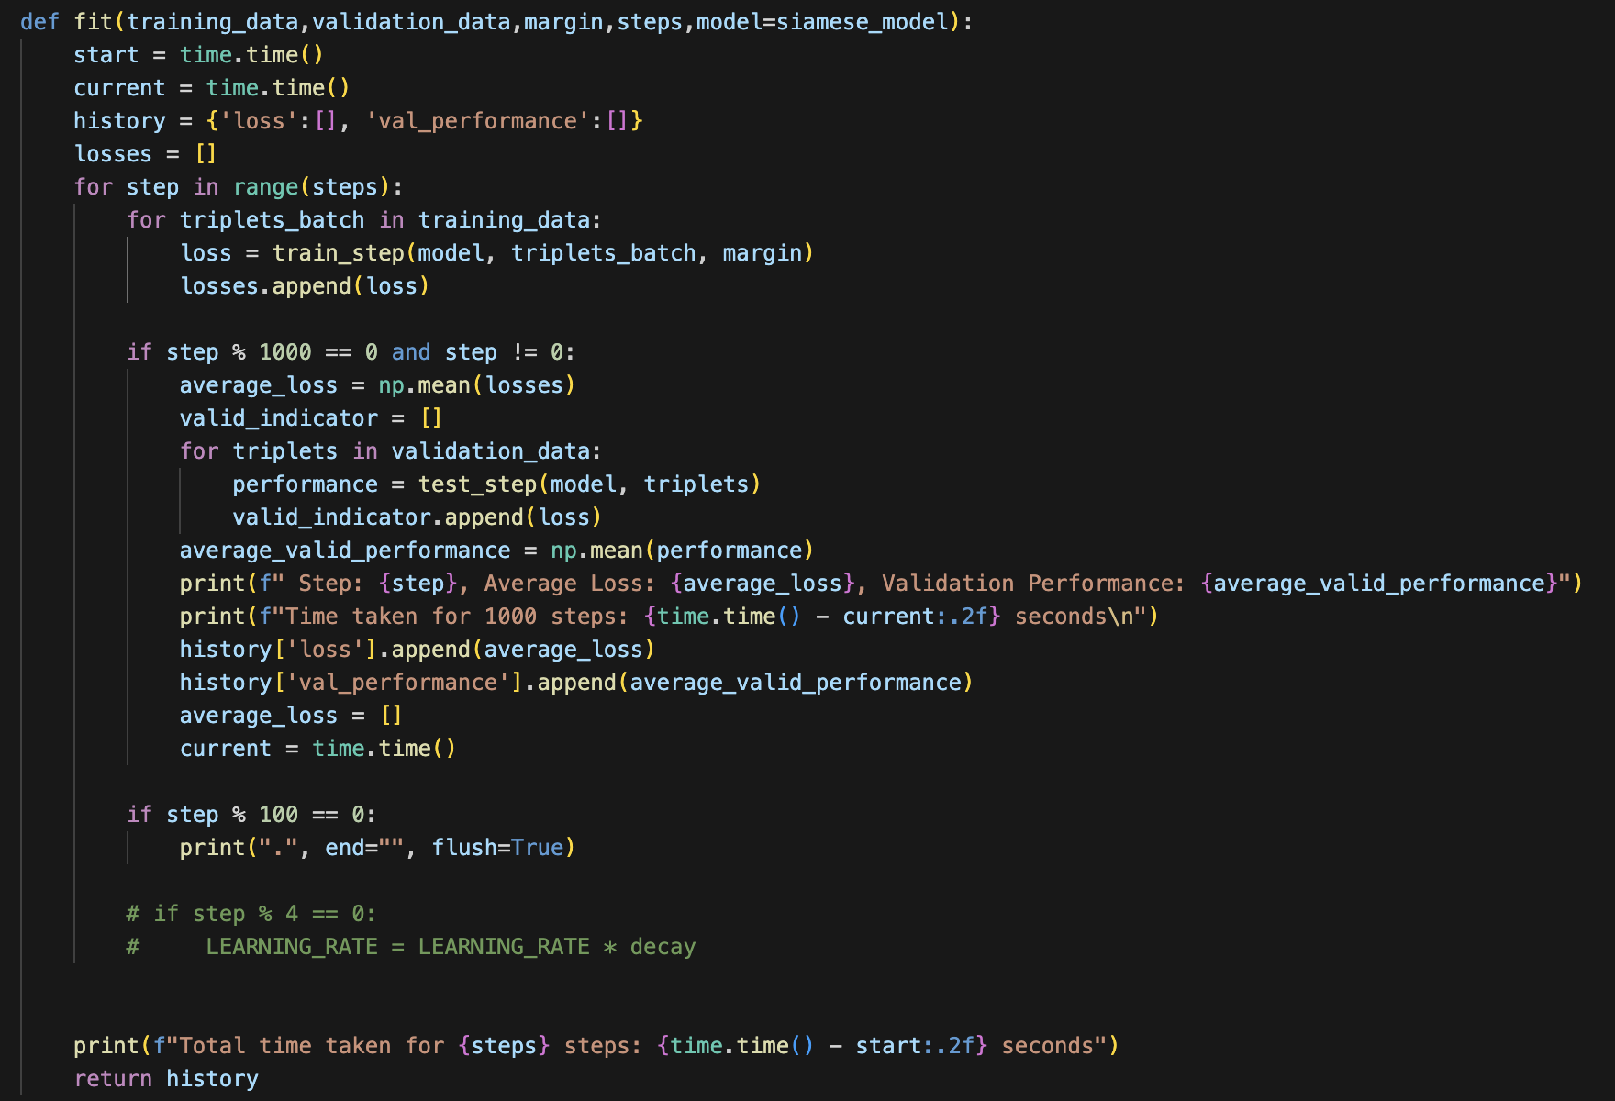

Fig 13. Code Implementation of Custom Fit Function



Fig 14. Code Implementation of Model Fitting

## **Initial Results:**

The model achieved validation accuracy of 85.5% after 50,000 episodes of training. While triplet training loss gradually decreases from 0.286 to 0.134, the validation accuracy increases in a fluctuated manner.

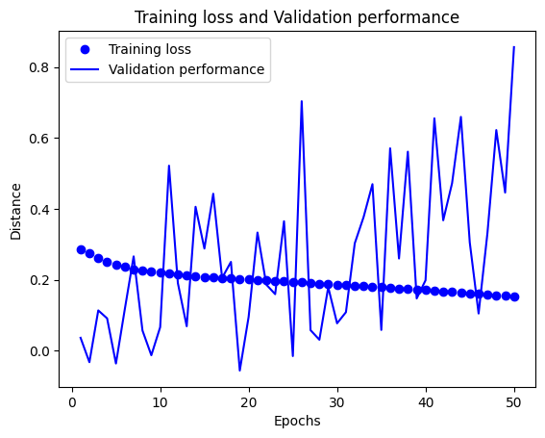

Fig 15. Model Training History

To further test the model’s ability to achieve a one-shot classification of faces, a custom face bank is set up consisting of the frontal face image of 6 different celebrities, mimicking a real-life scenario. Afterwards, a random celebrity’s face is presented to the model and the model should compare the face with all faces in the face bank to output an outcome. In this case, the model is unable to classify accurately the celebrity. It outputs a distance of 5.479 when comparing pictures of Ed Sheeran and a distance of 5.004 between Ed Sheeran and JJ Lin. All distances between the face presented and the face bank output by the model land above 5, showing no obvious effect that the triplet loss has done in minimizing the distance between anchor and positive images and the user is unable to tell the threshold output that faces will be classified as matched.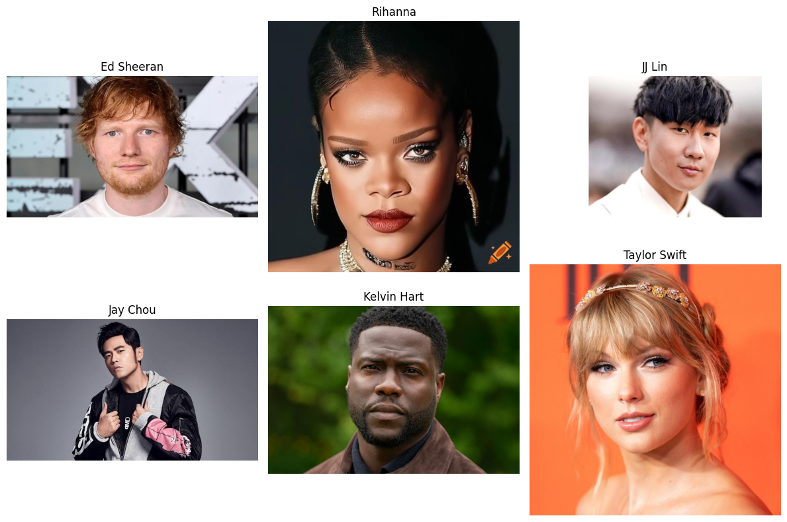

Fig 16. Sample Face Bank

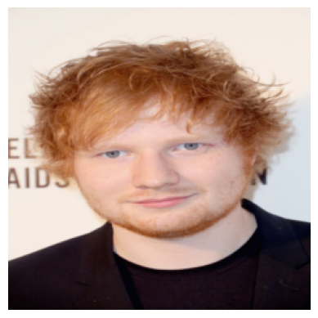

Fig 17. Photo of Person of Interest

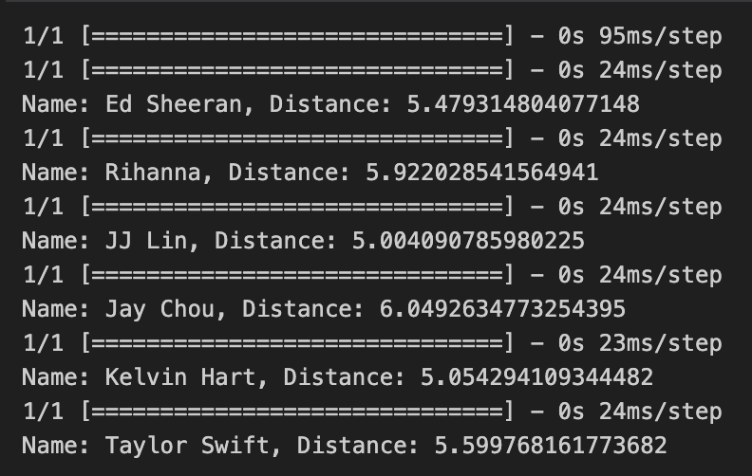

Fig 18. First Model Performance

## **Siamese Contrastive Model**

The Model’s suboptimal performance might be a result of over-relying on the implemented triplet loss. The loss function can only help with maximizing the distance between anchor and negative images, while the distance shown does not contain additional information such as the confidence of a model in whether 2 images are a match.

To address the problem, changes are made to the neural network structure. Instead of taking in one image at a time, output the embedding and rely on an external function (Triplet loss) to calculate the distances between images. the updated model now takes in pairs of images, extracts information from the image using the same block of information-extracting layers, calculates the Euclidean distance, and has a fully connected dense layer activated by the Sigmoid function to output the confidence of the model such that the images are from the same person.

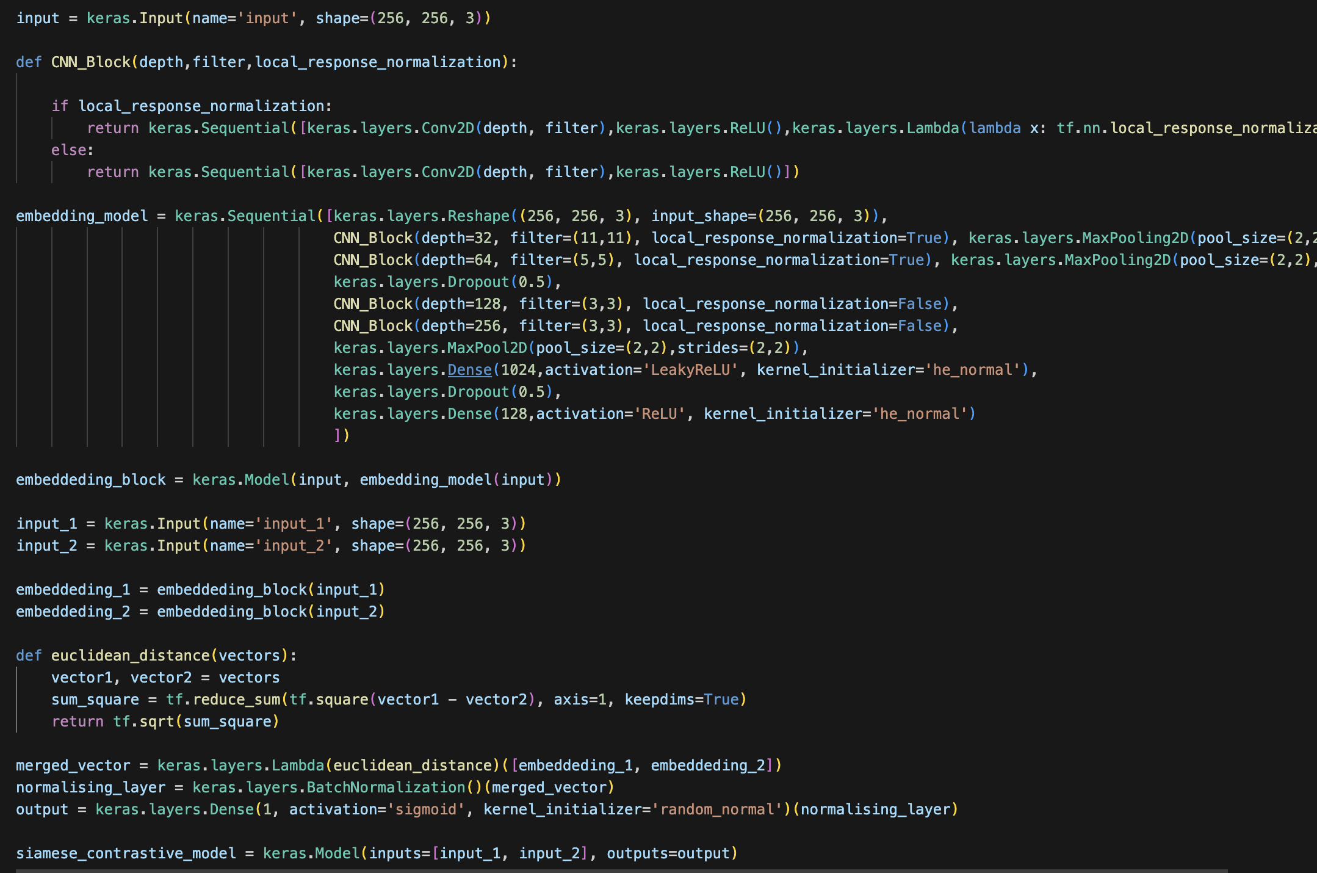

Fig 19. Code Implementation of the Siamese Contrastive Model

Training data are prepared separately as well. Instead of a triplet of images, images are now grouped as pairs with a binary label. Label 0 means that the images are from the same person and label 1 means otherwise. To achieve that the same folder containing people with more than 5 images is used. Different images of each person were grouped as pairs and were given a label of 0. Through doing that, 4230 positive pairs were obtained. To generate negative pairs, images were selected at random in the main LFW dataset. A total of 4500 pairs of negative image pairs were generated.

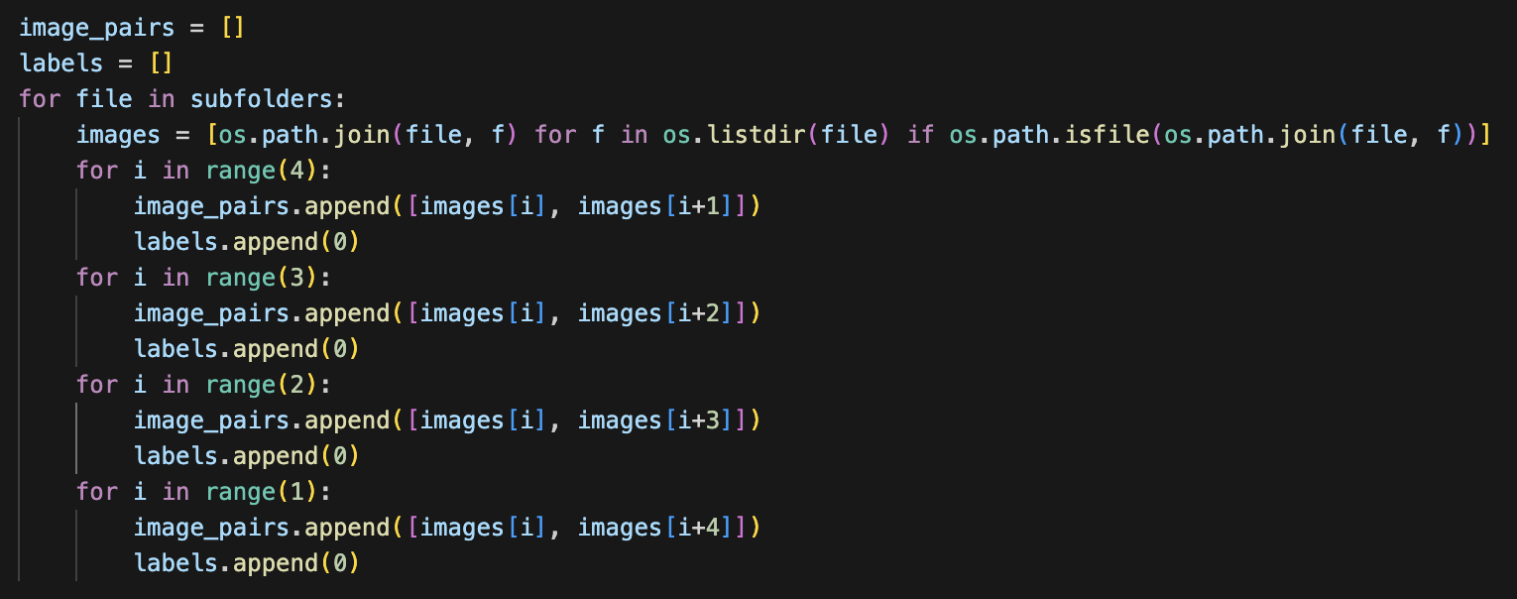

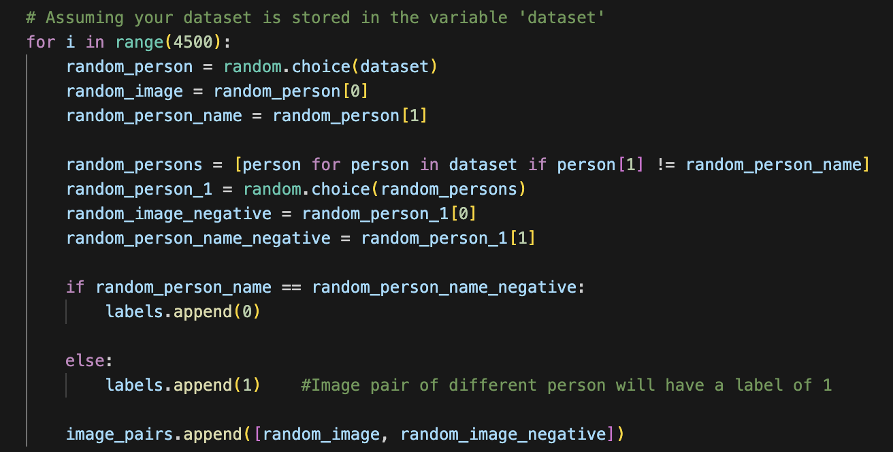

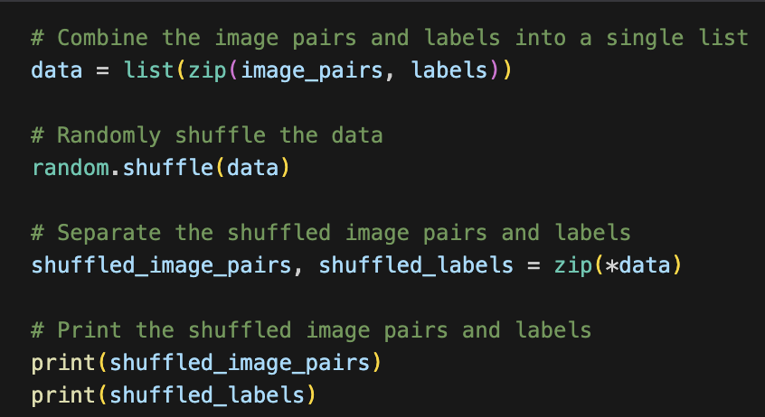

Fig 20&21&22. Code Implementation to Prepare Image Pairs

Lastly, a new contrastive loss is defined to replace triplet loss. Contrastive loss serves similar function to binary cross entropy loss, where a label of 0 can be seen as 0 distance between the 2 image and a label of 1 shows maximum distance between the 2 images. Loss is calculated as the difference between the output of contrastive model and the label. Margin is also included in this contrastive loss to ensure that loss is not negative.

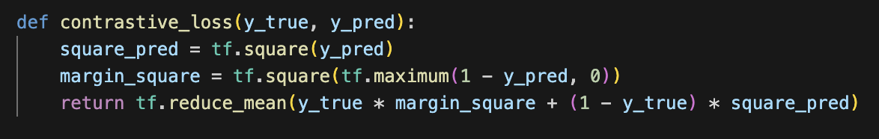

Fig 23. Code Implementation to define Contrastive Loss

The new model is trained at batch size of 32. This ensures sufficient data are fed to the model at once, preventing the model from learning nonsensical features. The model is trained for 10 episodes, allocating enough computer resources for the model to converge.



Fig 24. Code Implementation to Set Training Hyperparameters

## **Siamese Resnet Contrastive Model**

The training of the new model was interrupted after only 1 episode of training. This is because the training loss is shown as NaN and it cannot be used in training the new model. This is a typical training problem called the vanishing gradient problem, a common reason to explain this occurrence is that during training, the majority of the network weights are set to 0, making close to 0 outputs consistently and the loss function cannot be calculated. 

Fig 25. Training History of Siamese Contrastive Model

To solve the issue, Residual Net Architecture was introduced in replacement of the model’s custom information extraction embedding block. ResNet architecture tackles the vanishing gradient problem by employing skip connections, known as residual connections, within its network structure. By learning residual functions instead of attempting to directly approximate the underlying mapping, ResNet allows gradients to flow more freely through the network during backpropagation. These skip connections, or shortcut connections, enable gradients to bypass intermediate layers where the vanishing gradient problem commonly occurs, ensuring smoother and more effective gradient propagation. Additionally, ResNet incorporates identity mapping shortcuts in cases where the input and output dimensions of a residual block match, further facilitating gradient flow. Alongside batch normalization layers, which stabilize activations within each layer, ResNet architectures can train very deep networks without encountering significant degradation in performance due to the vanishing gradient problem.

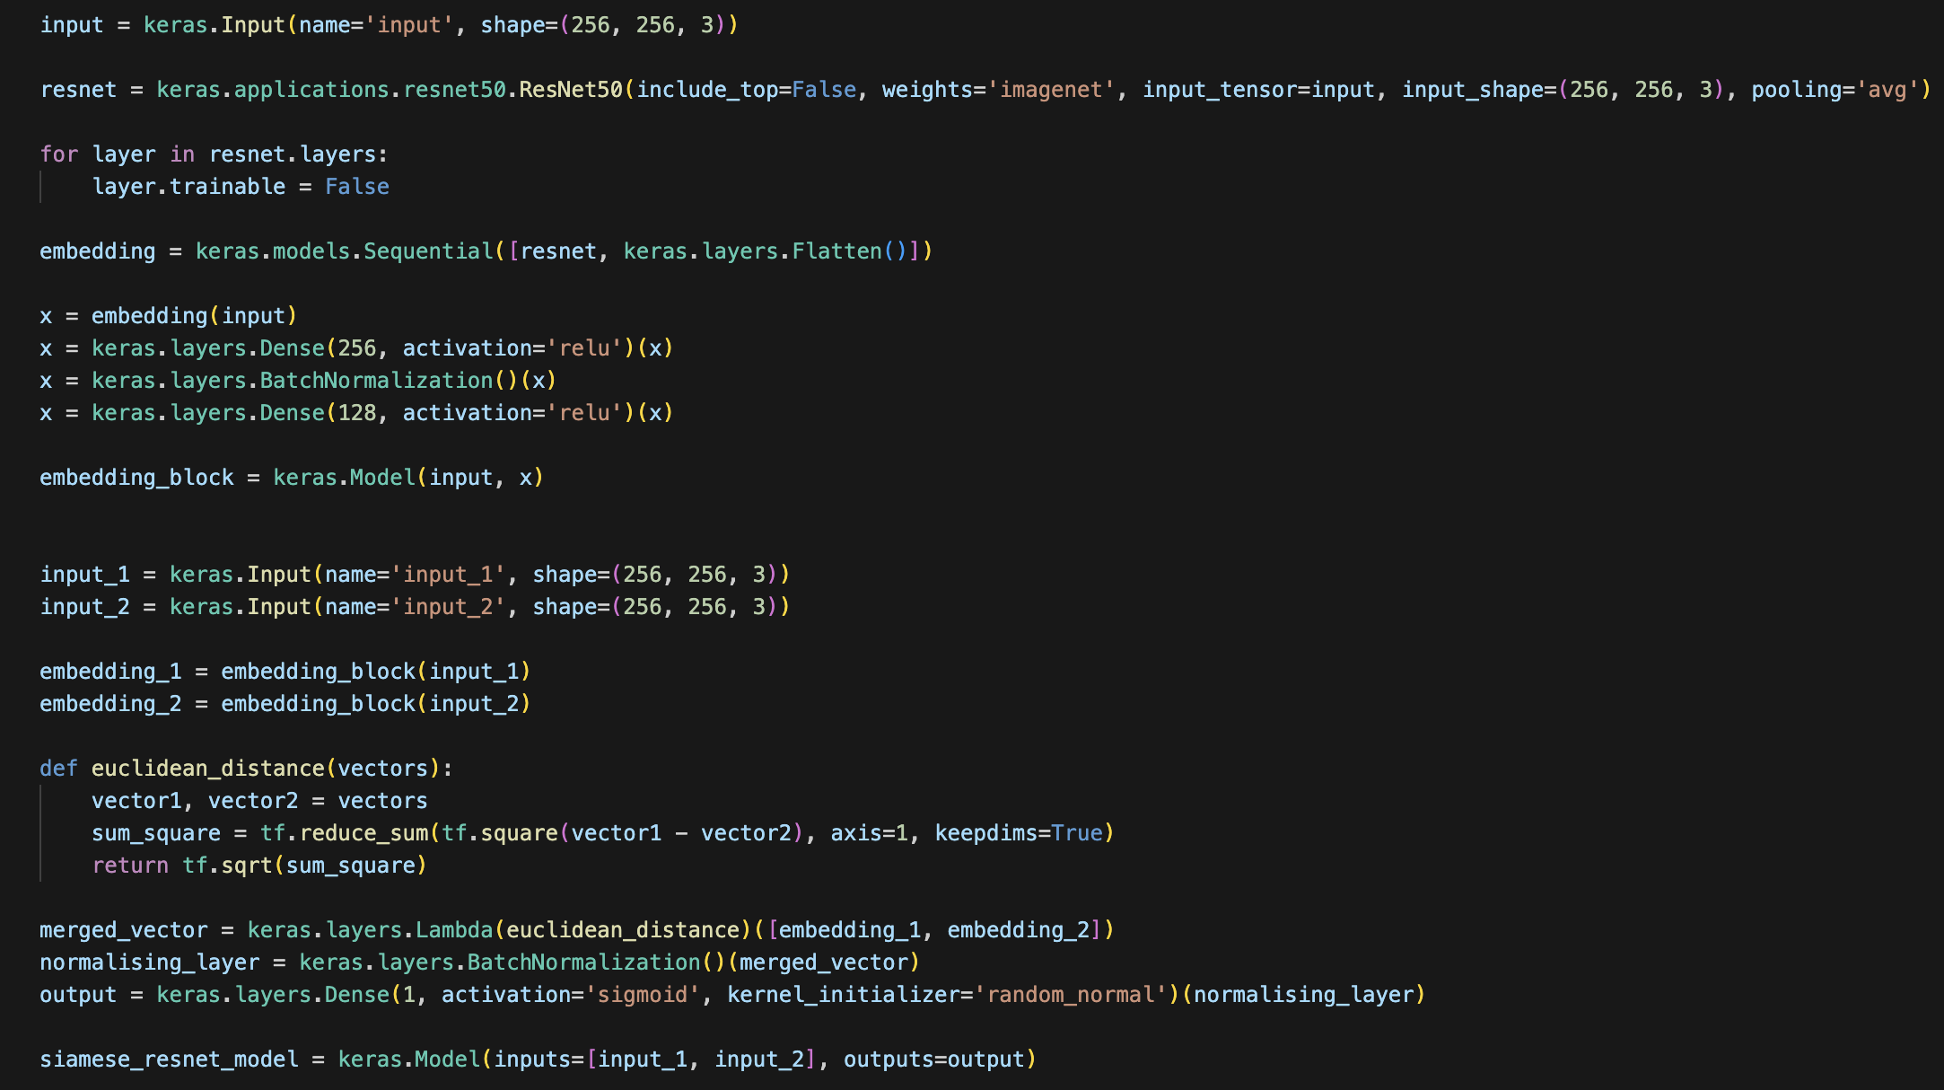

Fig 26. Siamese Resnet Contrastive Model Which Replaces Embedding Block with Resnet

## **Intermediate Result**

The model’s validation accuracy fluctuates around 55% after reaching the highest validation accuracy of 60.77% in episode 6.

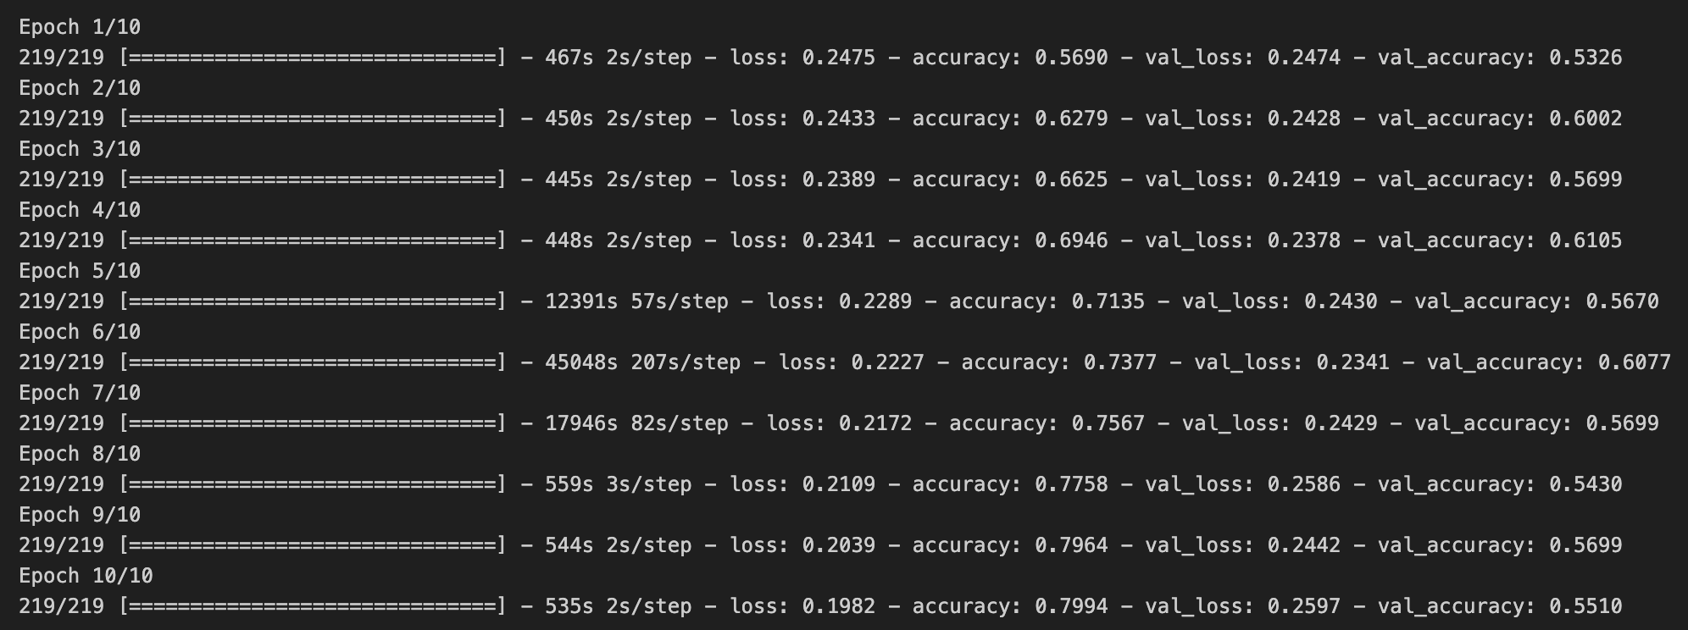

Fig 27. Siamese Resnet Contrastive Model Training History

Testing the model on the custom face bank still shows negative result. Taking 0.5 as a threshold, the model predicts no match between every single celebrity and Ed Sheeran’s picture. What is worse is that the output between pictures of Ed Sheeran is at 0.64, which is lower than the output between Ed Sheeran and pictures of other celebrity such as Taylor Swift.

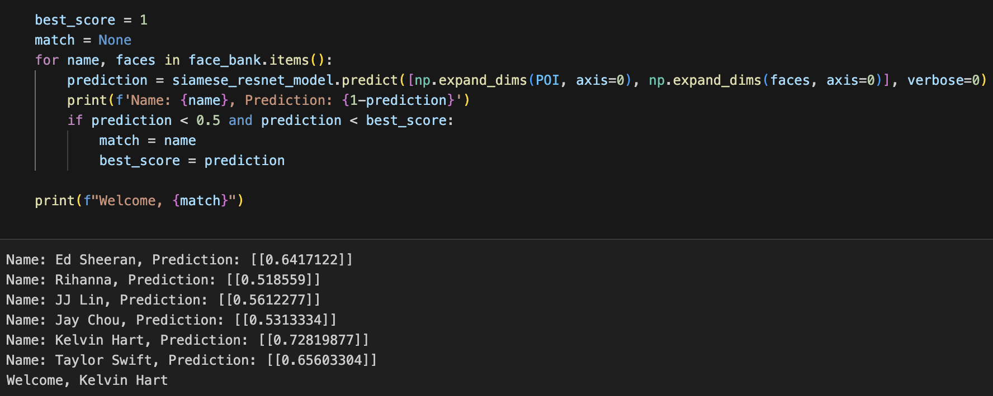

Fig 28. Siamese Resnet Contrastive Model Testing Result

## **Siamese Cosine Similarity Model**

While the reason for the suboptimal performance of the contrastive model is not identified, a possible suspicion is due to the network architecture and redundant information in the training dataset. The 2 probable reasons will be addressed separately to investigate the effect.

The first suspicion is due to the architecture of the Siamese contrastive model. Euclidean distance between 2 images might not be the most effective way to determine if the 2 images belong to the same person, as it can affect the magnitude of the output embedding vector, which can be affected by various reasons such as the color of the picture.

To effectively determine if pictures are from the same person, another way of determining called the cosine similarity can be used. Cosine similarity is a measure used to determine the similarity between two vectors in a multi-dimensional space. Specifically, it measures the cosine of the angle between the two vectors, indicating the extent to which they point in the same direction. In the context of one-shot classification, cosine similarity is particularly useful for comparing feature embeddings extracted from images.

Cosine similarity is implemented in the model by replacing the process of calculating Euclidean distance to a dot product layer from Keras. With normalization set to true, the dot product layer can be used to calculate the cosine similarity between 2 images. The training loss will be updated to binary cross entropy this time since similarity can be seen as classification.

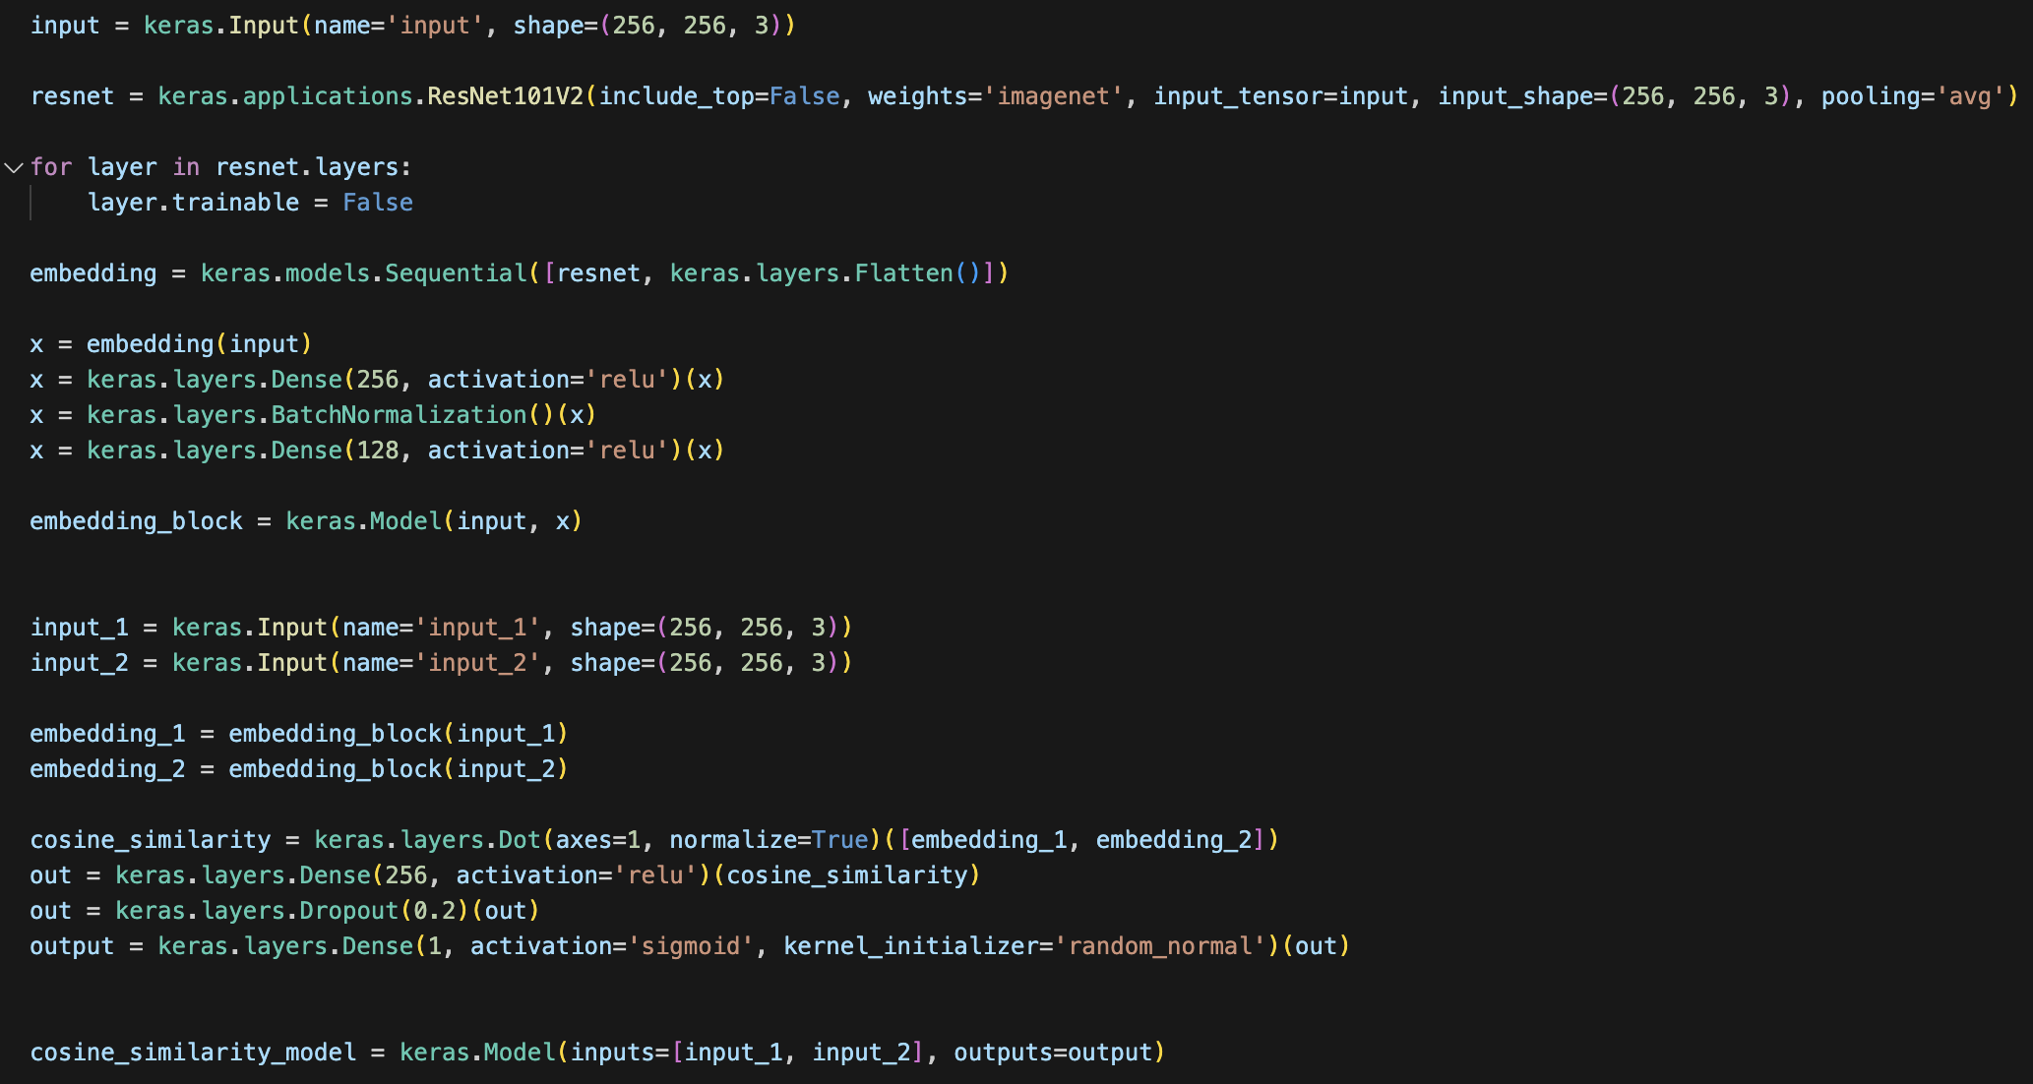

Fig 26. Siamese Cosine Similarity Model by Introducing Dot Layer

## **Intermediate Result**

The model achieved a validation accuracy of 94.1% after 20 episodes of training. Putting the model to the test, now it can successfully match Ed Sheeran’s pictures, however, some other potential matches process decently high results as well. To further fine-tune the model, face extraction will be performed to investigate the effect of having a dataset without redundant background noise.

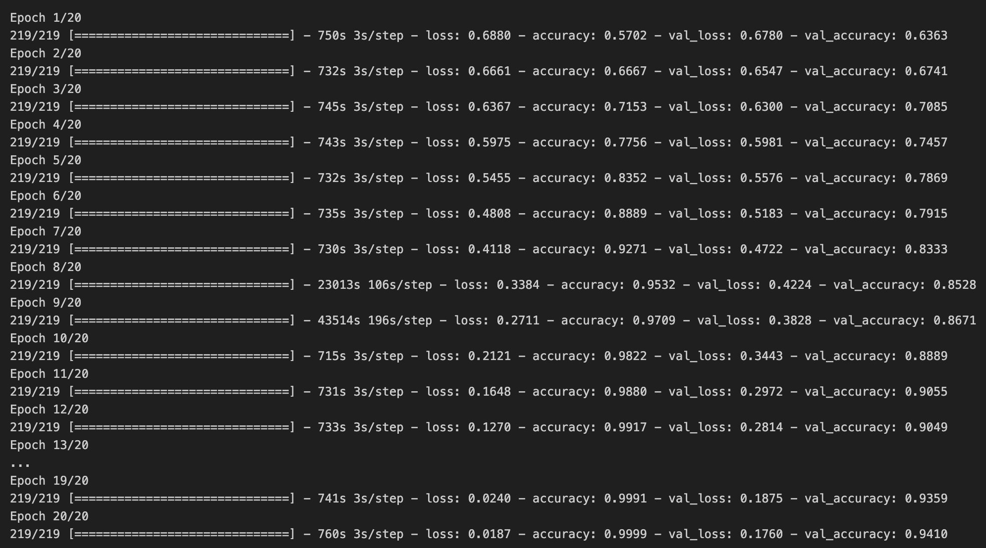

Fig 27. Siamese Cosine Similarity Model Training Result

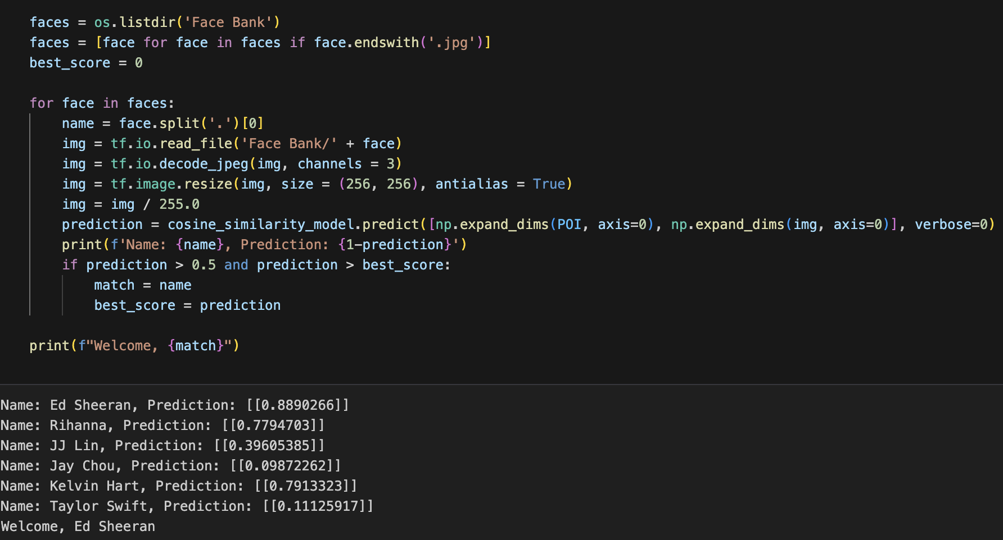

Fig 27. Siamese Cosine Similarity Model Testing Result

## **Face Extraction**

The LFW dataset contains images of different celebrities on various occasions, making the image background vastly different. The area of interest which is the face, often takes up only a quarter of the whole image. This can affect the model as it might pick up unwanted information from the background and use it in its decision-making process. To address the problem, faces in each image can be extracted and training of the model can be done only using the faces as training data. In this project, we will use the existing HaarCascade to aid the process of face extraction and preprocessing.

Haar Cascade is a machine learning-based object detection technique used to identify objects in images or video streams. It works by training a cascade classifier with positive and negative samples of the target object, learning patterns of pixel intensities that distinguish the object from its background. During detection, the Haar Cascade classifier slides over the image at different scales and locations, identifying regions that match the learned patterns. In face extraction, Haar Cascade classifiers specifically trained for faces can accurately locate and extract faces from images or video frames. This technique is efficient for real-time applications and serves as a foundational method for face detection and recognition tasks, enabling various applications such as video surveillance, facial recognition systems, and augmented reality filters.

To preprocess the model:

1. **Defining a Function to Extract Faces from Images**: The preprocessing begins by defining a function that utilizes Haar Cascade to locate and extract faces from input images. This function takes an image as input, applies the face detection algorithm to identify faces, and crops the detected faces from the original image. The extracted faces are then saved as individual images or stored in memory for further processing.

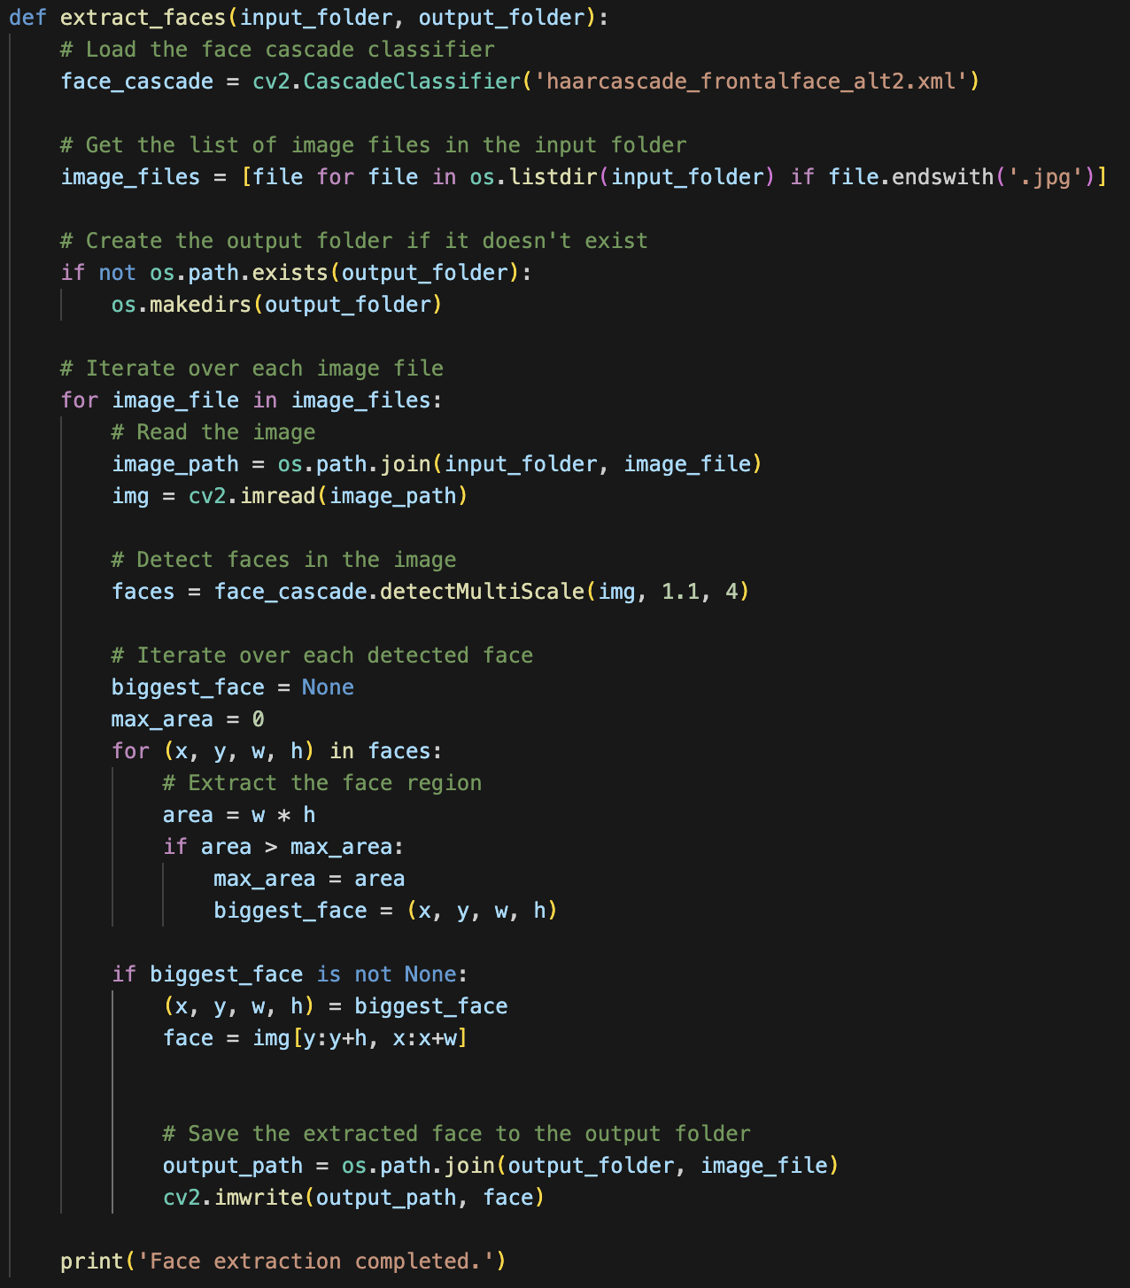

Fig 28. Face Extraction Function

1. **Accessing All Folders and Calling the Face Extraction Function**: Next, the preprocessing script traverses through all subfolders previously identified within the main dataset directory, each representing an individual's collection of images. For each subfolder, the script calls the previously defined face extraction function to process all images contained within the folder. By iterating through each folder, the script ensures that all images are processed, and faces are extracted from each individual's photo collection.
2. **Storing Extracted Faces in a Separate Folder**: As faces are extracted from each image, the preprocessing script stores the extracted faces in a separate folder designated for processed data. This folder acts as a repository for the preprocessed images, ensuring that the extracted faces are organized and easily accessible for subsequent steps in the pipeline.



Fig 28. Face Extraction and Save Output to Target Folder Code Implementation

1. **Repeat Other Preprocessing Tasks**: Once all faces are extracted, other steps of preprocessing are repeated such as data loading, image translation and dataset preparing.

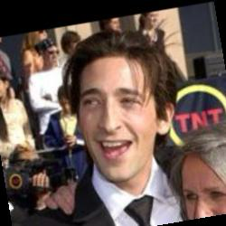

Fig 29&30 Sample Image Before and After Extraction



Fig 31. New Dataset Splitting Using Train Test Split

## **Final Result**

The model achieved a validation accuracy of 75.60% after 25 episodes of training, Testing the same Ed Sheeran image with the face bank returns a matching result, and the prediction of 2 Ed Sheeran’s image are higher as compare to the model output with Ed’s picture and other pictures in the face bank, showing positive improvement to the model performance.

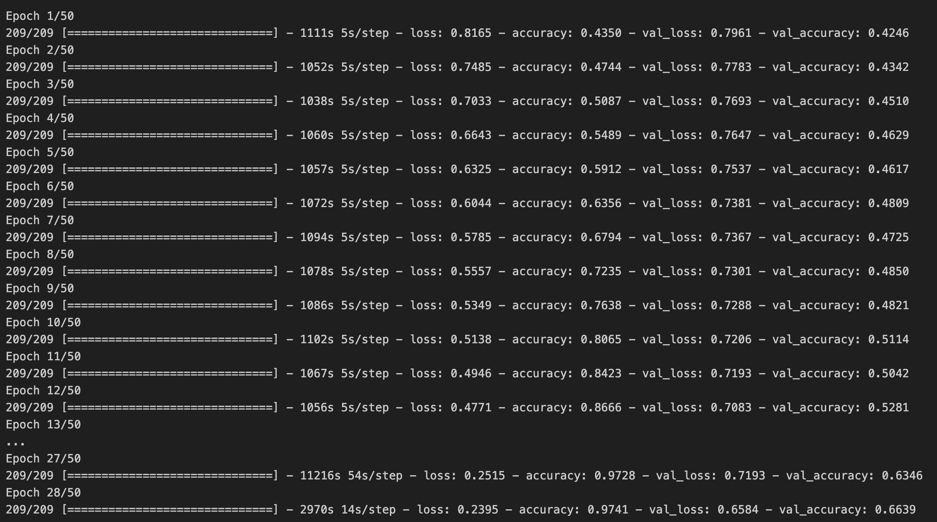

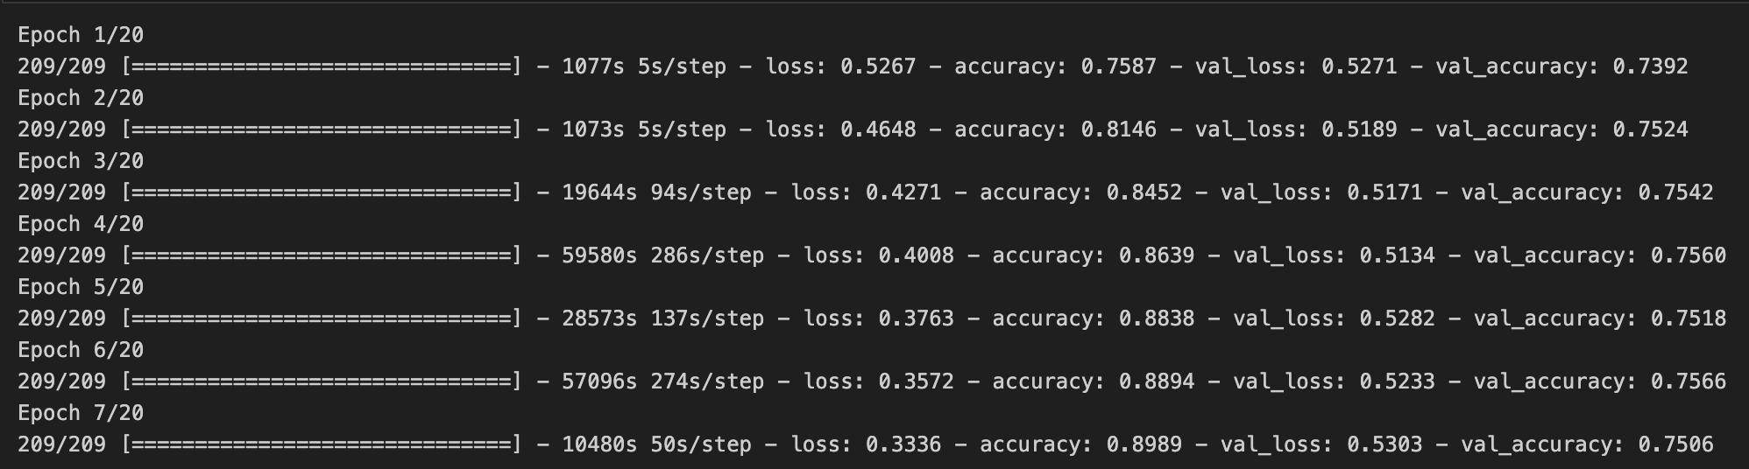

Fig 32&33. Siamese Cosine Similarity Model Training History

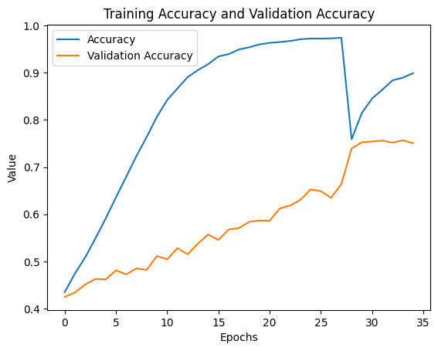

Fig 34. Siamese Cosine Similarity Model Training History Visualization

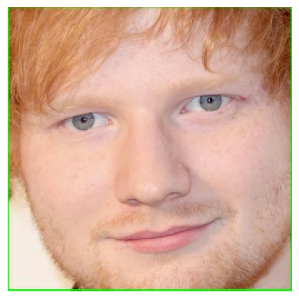

Fig 35. Extracted Face from Person of Interest

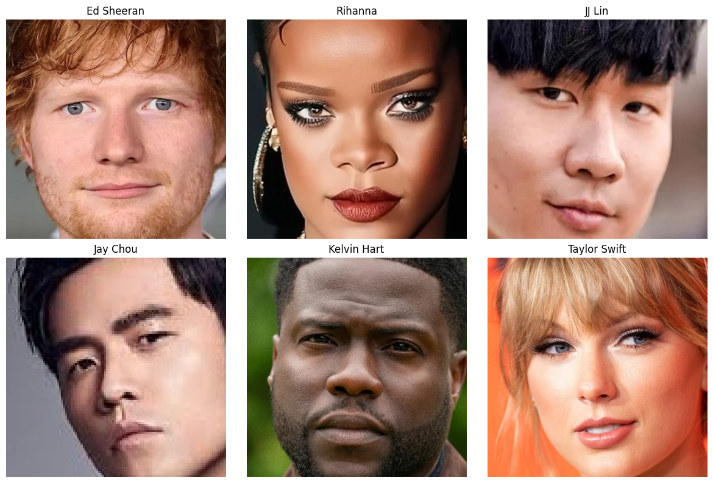

Fig 36. Extracted Face Bank

## **Potential Improvements**

Some potential improvements that can be implemented includes:

* 1. Further finetune the model by changing hyperparameters.
  2. Testing model with more images and a larger face bank to get better and fairer assessment to a model’s performance.

## **Conclusion:**

In conclusion, this project has not only explored the application of Siamese Networks for one-shot classification but has also implemented various Siamese models to understand their strengths and limitations. Through meticulous experimentation with different architectures, including variations in network depth, convolutional layers, and embedding techniques, the project gained valuable insights into the performance characteristics of each model.

By systematically evaluating the effectiveness of different Siamese architectures, the project identified key limitations such as computational complexity, overfitting, and sensitivity to hyperparameters. These findings underscored the importance of thoughtful design choices and rigorous experimentation in developing robust and reliable Siamese Network models for one-shot classification tasks.

Furthermore, the project's exploration of diverse Siamese architectures deepened its understanding of the underlying principles governing feature extraction, similarity measurement, and decision-making in one-shot classification scenarios. By critically assessing the performance of each model against real-world datasets and benchmark tasks, the project gained valuable knowledge about the trade-offs involved in choosing an appropriate Siamese architecture for specific applications.

In summary, this project's comprehensive investigation into different Siamese models has enriched its understanding of the nuances and challenges inherent in one-shot classification tasks. By recognizing and addressing the limitations of each architecture, the project has paved the way for future advancements in Siamese Network research and applications, contributing to the ongoing evolution of computer vision methodologies.